BIT 4107 – Mobile Application Development
ENHANCED PROFESSIONAL STUDENT LOGBOOK
Student Name: KEFA VINCENT
Admission Number: BIT/2024/54140
School/Faculty: School of Computing and Informatics
Program: BIT4107-Mobile Application Development
Academic Year: 2026
Semester: 3.2
Lecturer: Mr. Nyoro
Phone Number:0114229447

Table of Contents
Setting up of the android Environment 4
Week 1: Introduction to Mobile Application Development 6
Practical Activities Undertaken 6
Tools/Software Used 6
Personal Reflection 6
Week 2: Mobile Development Environment 7
Tools/Software Used 7
Personal Reflection 7
Week 3: User Interface Design 8
Tools/Software Used 8
• Android XML 8
• Material Design 3 8
Personal Reflection 8
Week 4: Event Handling and User Interaction 9

Figure4.1. Navigation Control: Linked the Bottom Navigation bar to switch between the Home and Profile activities 9
Tools/Software Used 9
• Kotlin (onClickListener) 9
• Activity Intents. 9
Personal Reflection 9
Week 5: Data Management 10
Tools/Software Used 10
• phpMyAdmin 10
• MySQL 10
• GSON library. 10
Personal Reflection 10
Week 6: Networking and APIs 11
Tools/Software Used 11
• Retrofit 2 11
• PHP 11
• XAMPP Apache 11
Personal Reflection 11
Week 7: Application Architecture 12
Tools/Software Used 12
• Kotlin 12
• Android Manifest 12
Personal Reflection 12
Week 8: Project Planning 13
Tools/Software Used 13
• Material CardView 13
• RecyclerView 13
Personal Reflection 13
Week 9: Device Features and Sensors 14
Tools/Software Used 14
• Android Styles & Themes 14
• Night mode resources 14
Personal Reflection 14
Week 10: Notifications and Background Services 15
Tools/Software Used 15
• PHP (Audit Logging) 15
• Toast API 15
Personal Reflection 15
Week 11: Mobile Security 16
Tools/Software Used 16
• PHP (Prepared Statements) 16
• MySQL UNIQUE constraints. 16
Personal Reflection 16
Week 12: Testing and Debugging 17
Tools/Software Used 18
• Android Logcat 18
• Chrome DevTools (to test API responses). 18
Personal Reflection 18
Week 13: Application Deployment 19
Tools/Software Used 19
• Android Manifest 19
• Android Build Menu. 19
Personal Reflection 19
➢ Preparing for deployment required a focus on compatibility. I learned how to optimize the app manifest to ensure the phone's hardware correctly communicates with the local XAMPP environment. 19
Week 14: Final Project Presentation 20
Semester Project Tracking 21
Project Title 21
Project Objectives 21
Project Requirements 21
Development Milestones 21
Testing Results 22
Lessons Learned 22
Future Improvements 22
End of Semester Reflection 23
Summary of Skills Acquired 23
Most Interesting Topic 23
Major Challenges Faced 23
How Challenges Were Overcome 23
Professional Growth Achieved 23
Overall Course Experience 23
Final Approval 24

Setting up of the android Environment
- Step by step installation of the android studio environment

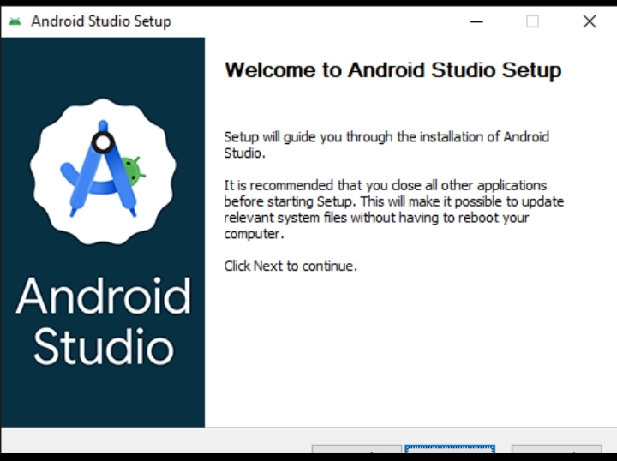
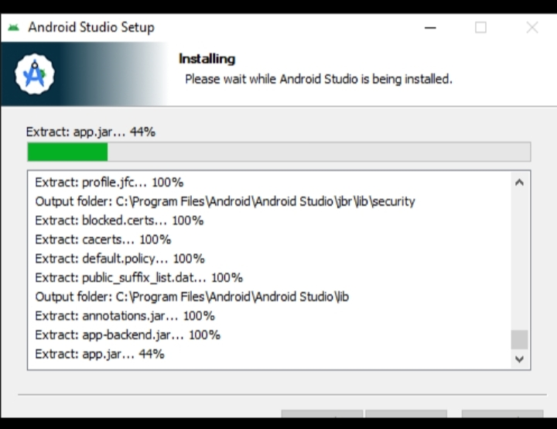
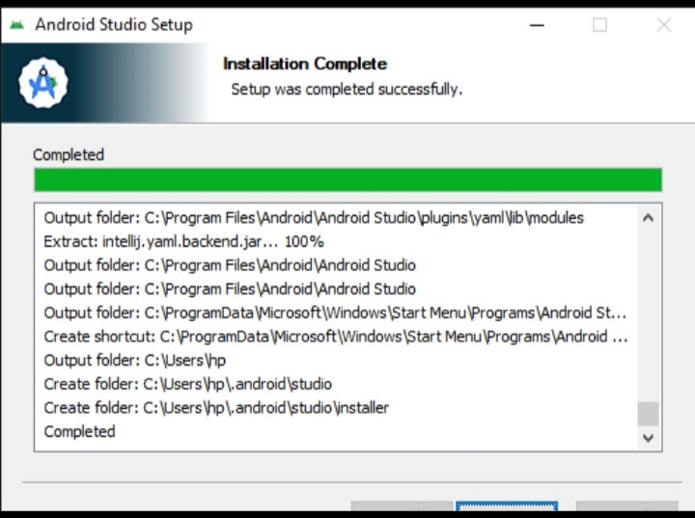
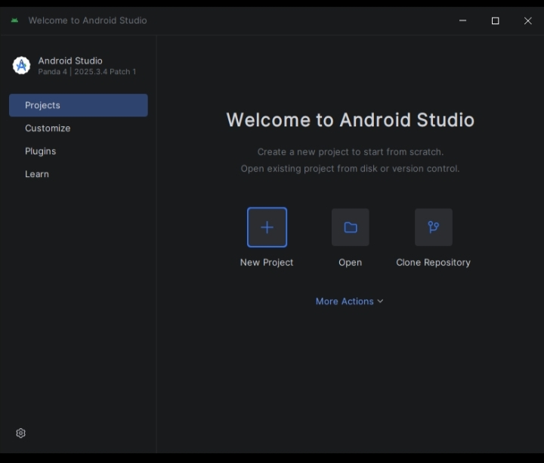

Week 1: Introduction to Mobile Application Development

Practical Activities Undertaken
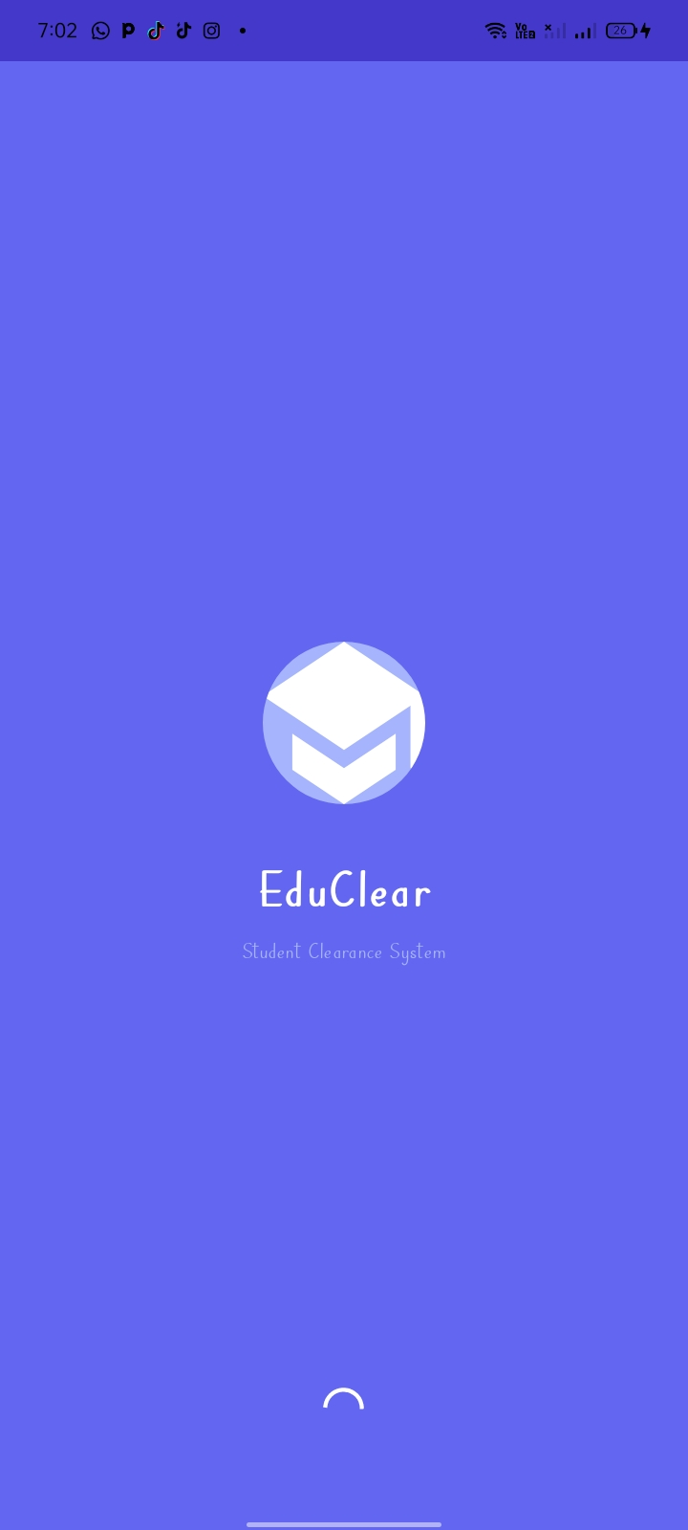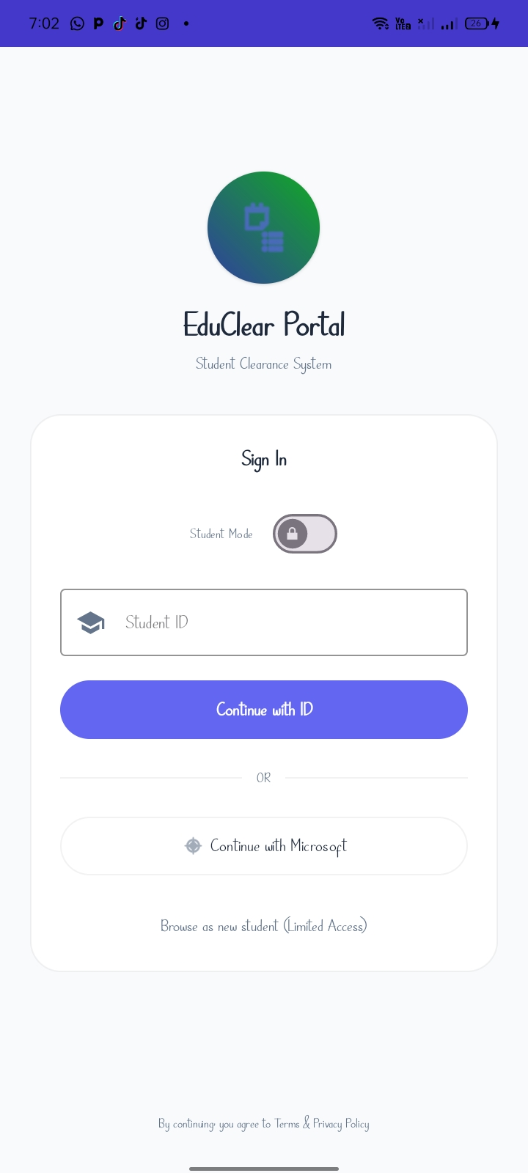
figure1.2.Splash Screen Interface: Created a figure1.2.Login Screen: created branded entry screen with the app for signing in users logo and loading bar.

Tools/Software Used
- Android Studio
- Vector Asset Studio

Personal Reflection
- This week I established the visual identity of the app. I learned how important first impressions are in mobile development and how a splash screen can be used to initialize background resources.

Week 2: Mobile Development Environment

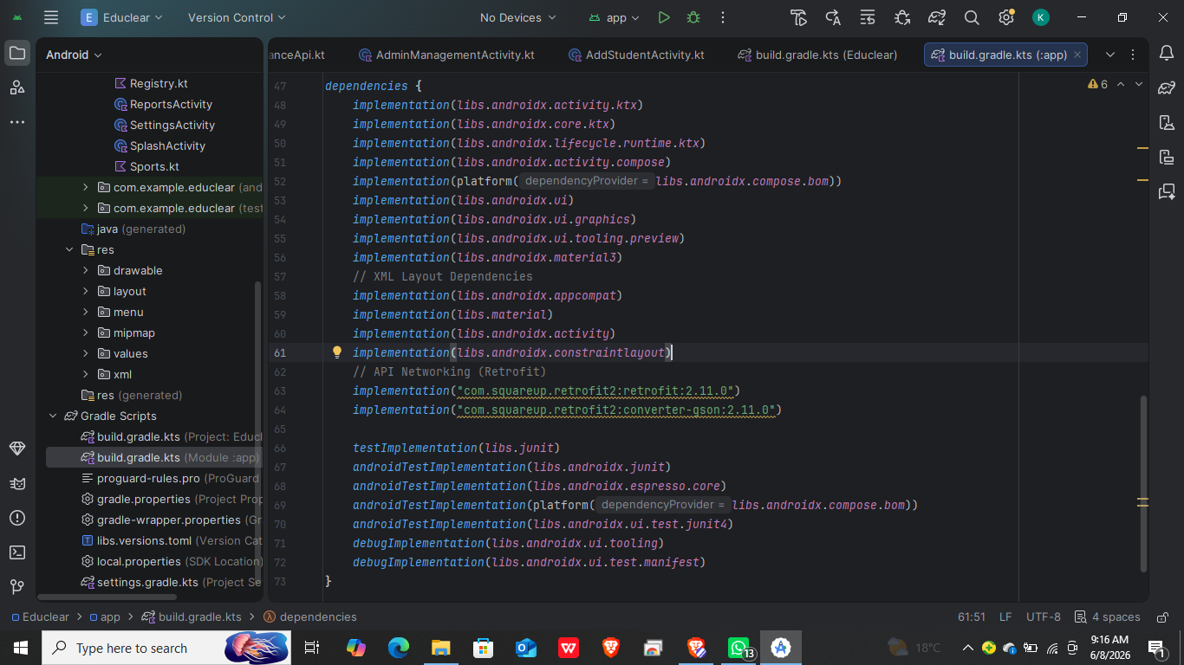
Figure 2.1. Build Configuration: Integrated Material 3 and Retrofit dependencies into the build.gradle file.

Tools/Software Used
- Android Studio
- Gradle

Personal Reflection
- Setting up the environment taught me how to manage external libraries. I realized that configuring network permissions is a critical step for apps that need to talk to a local XAMPP server.

Week 3: User Interface Design

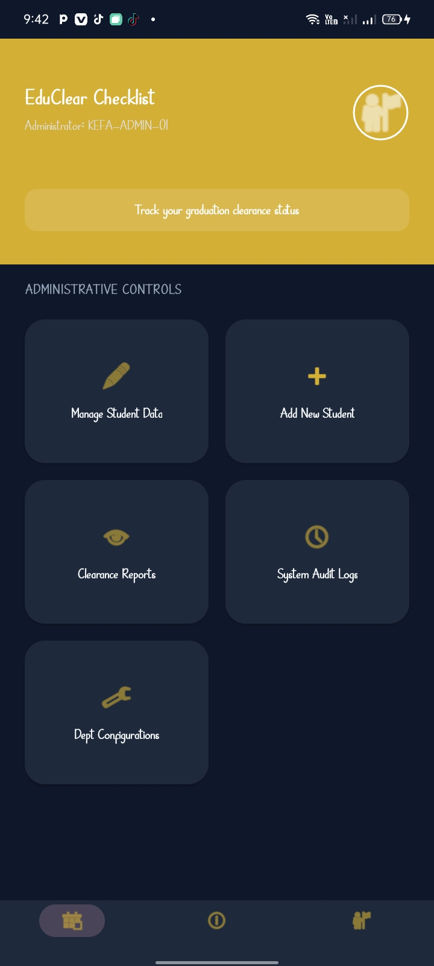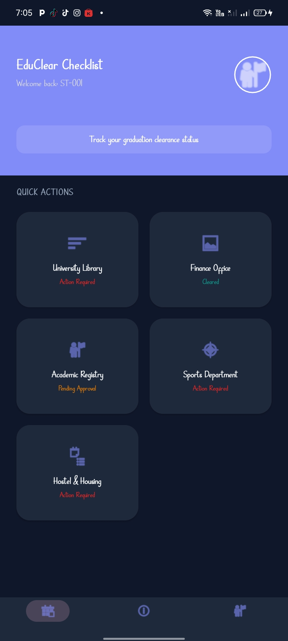
Figure 3.1. Admin dashboard figure 3.2. Student dashboard

Tools/Software Used

Android XML

Material Design 3

Personal Reflection
- I focused on modern aesthetics using deep rounded corners and shadows. I learned how to use themes to maintain visual consistency across all the different department pages of the app

Week 4: Event Handling and User Interaction

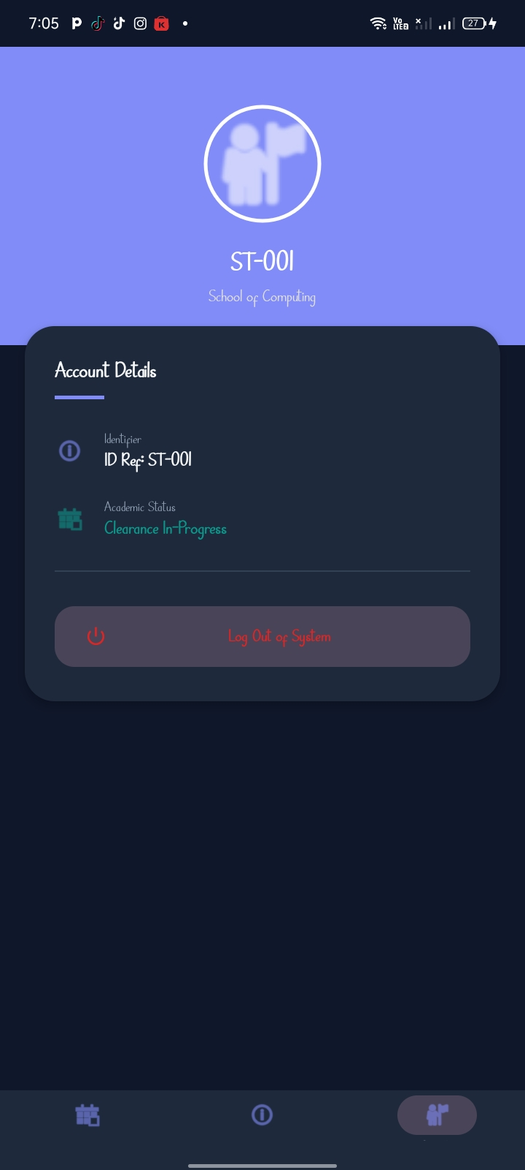

Figure4.1. Navigation Control: Linked the Bottom Navigation bar to switch between the Home and Profile activities

Tools/Software Used

Kotlin (onClickListener)

Activity Intents.

Personal Reflection
- This week was about making the app interactive. I learned how to pass data between screens using Intent Extras, ensuring the user's ID follows them from login to the profile page.

Week 5: Data Management
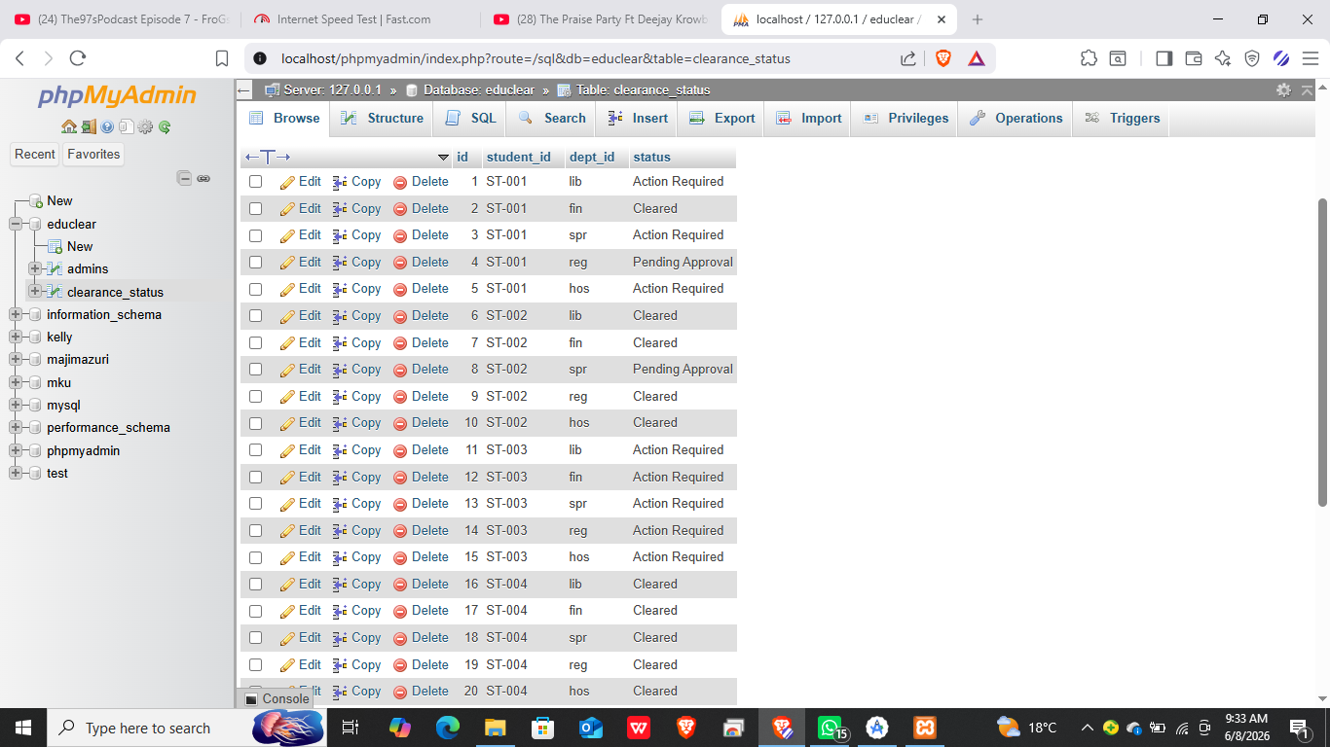figure 5.1. Created MySQL tables in XAMPP for students, admins, and clearance statuses.

Tools/Software Used

phpMyAdmin

MySQL

GSON library.

Personal Reflection
- I learned how to structure relational data for a clearance system. Creating a "one-box-per-student" view required careful planning of how data is fetched and grouped by the backend API.

Week 6: Networking and APIs
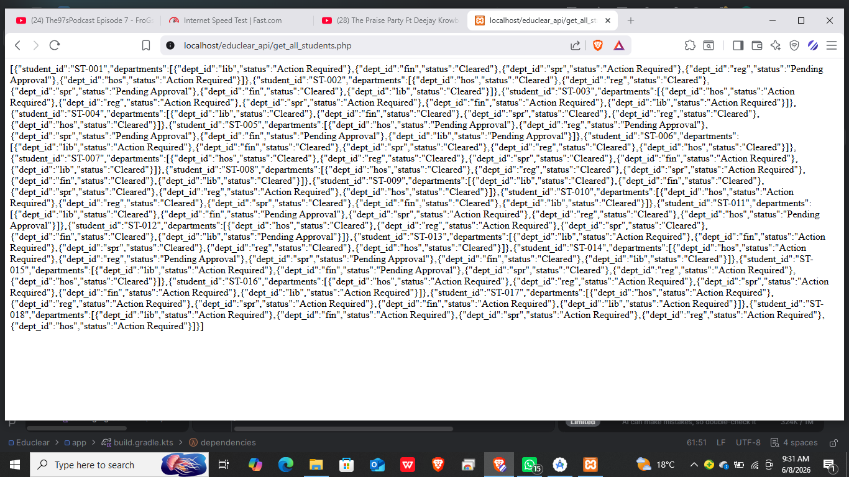figure 6.1. Wrote PHP scripts to handle student login and clearance status retrieval.

Tools/Software Used

Retrofit 2

PHP

XAMPP Apache

Personal Reflection
- This was the most technical week. Connecting the app to a live database made the project feel real. I learned how to handle network errors and loading states gracefully for the user.

Week 7: Application Architecture
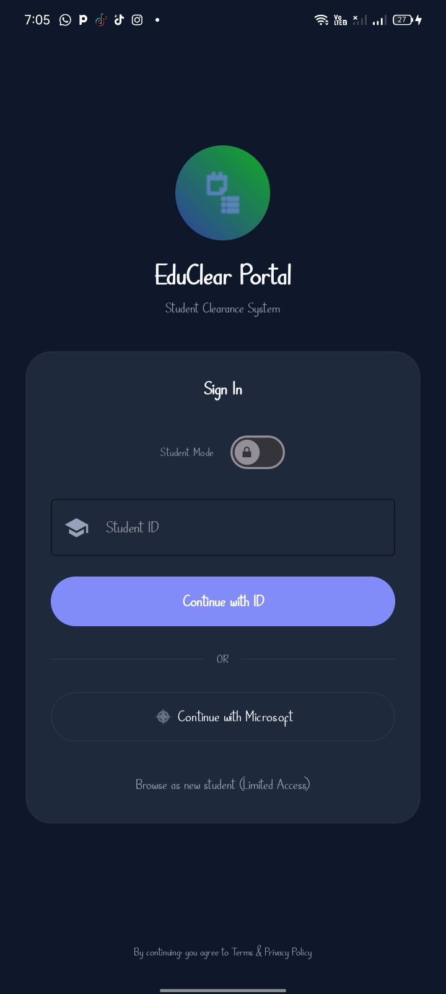
Figure 7.1. Admin/Student Logic: Implemented a login switch that branches the app into two separate functional modes i.e. student mode and admin mode.

Tools/Software Used

Kotlin

Android Manifest

Personal Reflection
- Building the dual-mode system taught me about role-based access control. I learned that a modular architecture makes the app easier to maintain as new features (like admin reports) are added.

Week 8: Project Planning

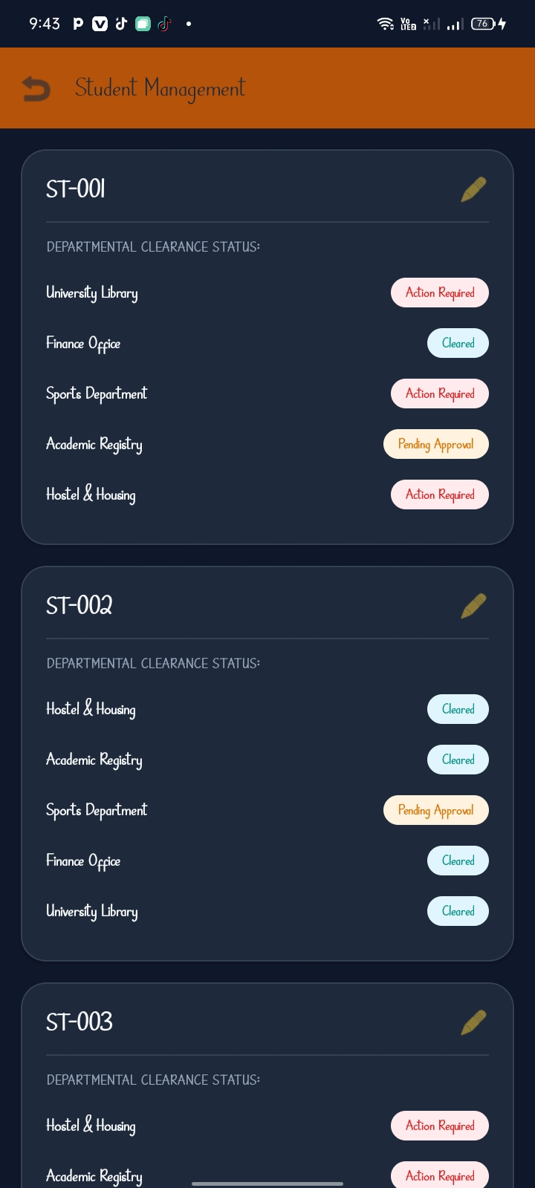
figure 8.1. Admin Management Hub: Designed a console for admins to view and edit student clearance statuses

Tools/Software Used

Material CardView

RecyclerView

Personal Reflection
- Planning the admin workflow helped me understand the importance of UX for managers. I focused on making the "Manage Students" screen intuitive so that clearance updates can be done in two clicks

Week 9: Device Features and Sensors

figure 9.1. Refactored all layouts to automatically adapt to system-wide mode settings Programmed the app to turn Gold in Admin mode and Blue in Student mode.

Tools/Software Used

Android Styles & Themes

Night mode resources

Personal Reflection
- Adding Dark Mode support made the app more accessible and modern. I learned how to use theme attributes to change colors dynamically without duplicating layout files.

Week 10: Notifications and Background Services
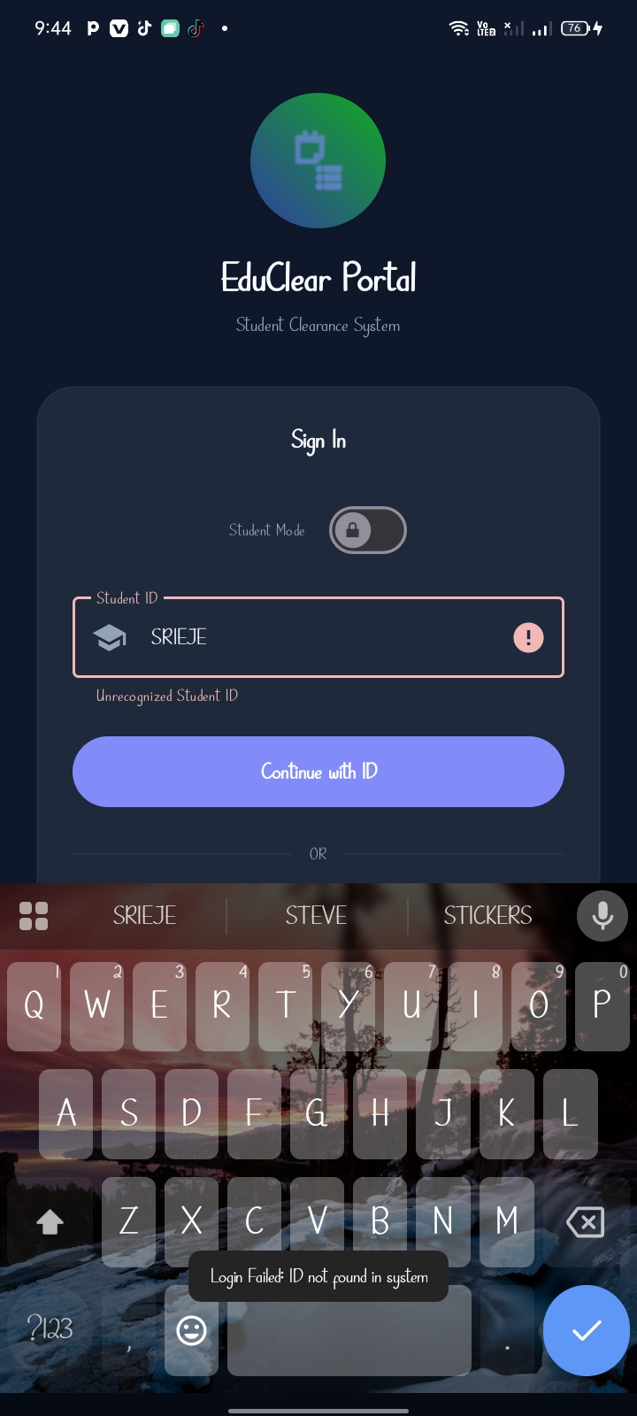
Figure 10.1. Toast Feedback: Implemented real-time status notifications for database updates and uploads.

Tools/Software Used

PHP (Audit Logging)

Toast API

Personal Reflection
- Implementing an audit log added security and accountability to the app. I learned that keeping a history of actions is just as important as the actions themselves in an enterprise system.

Week 11: Mobile Security
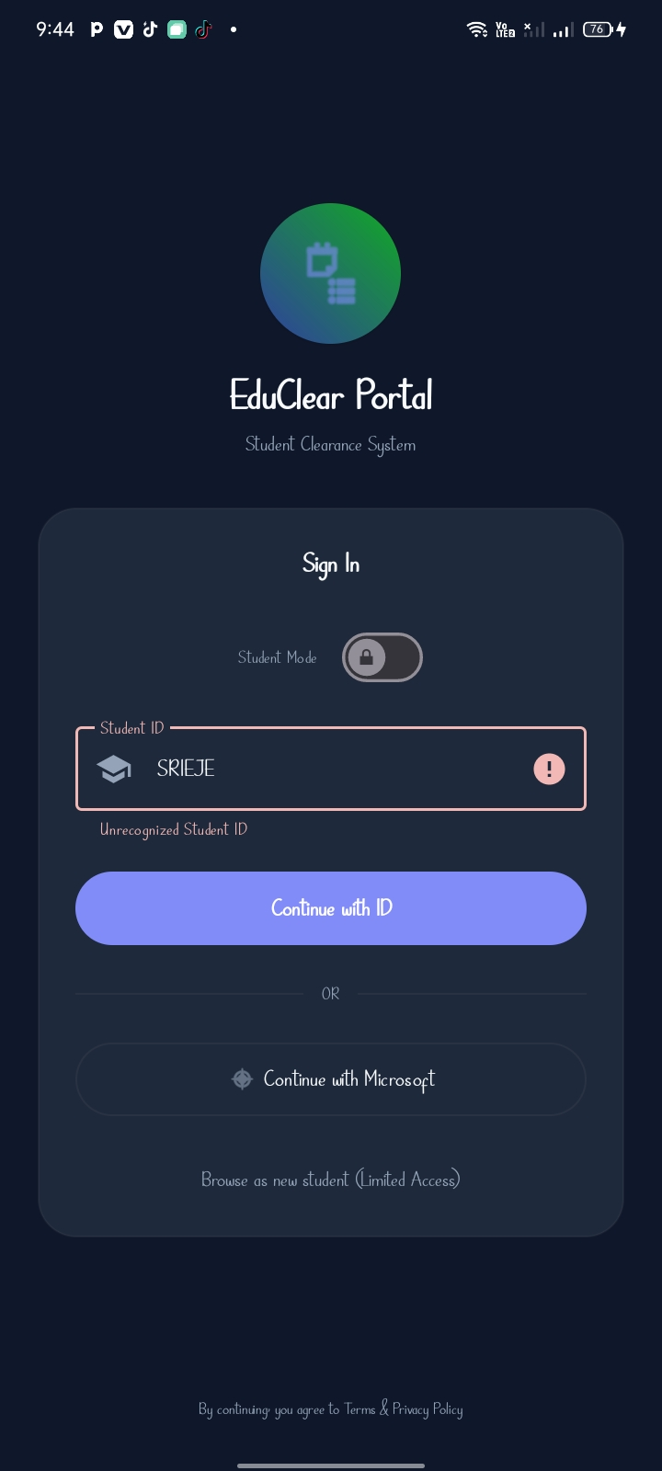
Figure 11.1. Restricted Access Control: Implemented a whitelist database for administrators to ensure only specific IDs (e.g., ST-001) can access root permissions.

Tools/Software Used

PHP (Prepared Statements)

MySQL UNIQUE constraints.

Personal Reflection
- Security is paramount in student data management. I learned that client-side checks aren't enough; true security must be enforced on the server to prevent unauthorized data manipulation.

Week 12: Testing and Debugging
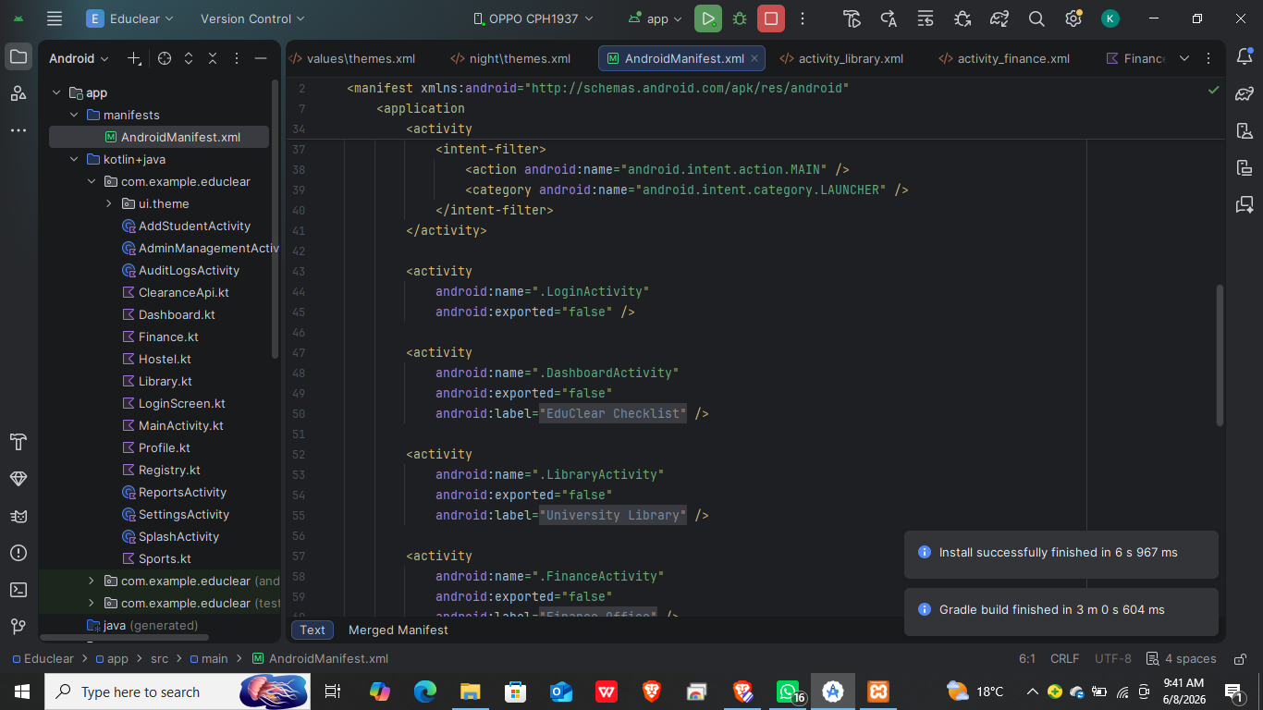
Figure 12.1. showing a successful build and installation
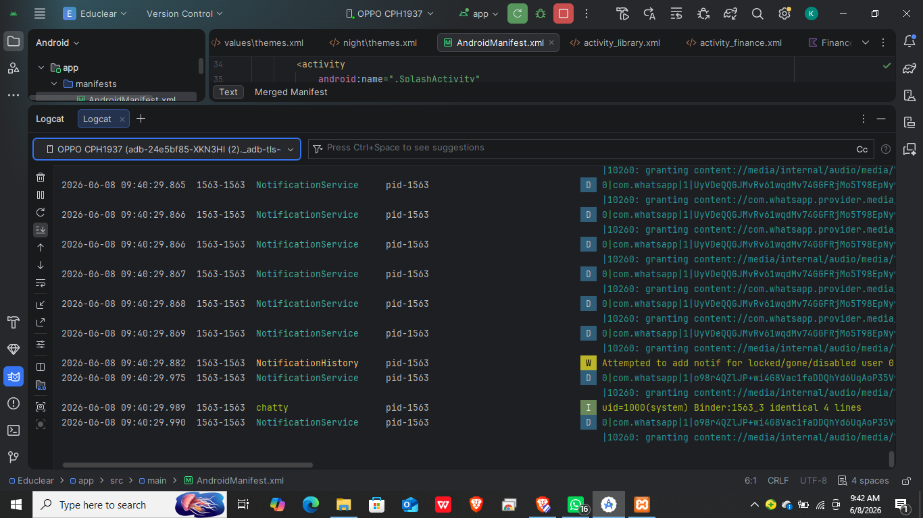
Figure 12.2. The Android Logcat window showing a "Successful Sync"

Tools/Software Used

Android Logcat

Chrome DevTools (to test API responses).

Personal Reflection
- This week improved my troubleshooting skills. Fixing the theme crash taught me how Material components rely on specific parent themes to initialize UI attributes correctly.

Week 13: Application Deployment
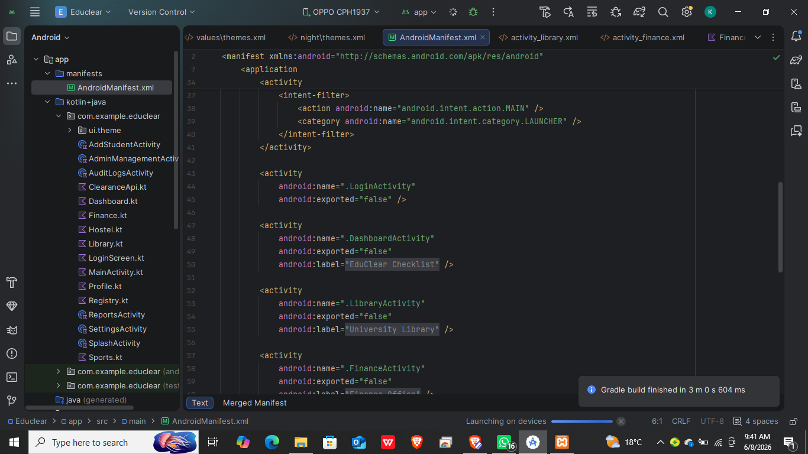
figure 13.1. The AndroidManifest.xml showing the activity declarations and Internet permissions

Tools/Software Used

Android Manifest

Android Build Menu.

Personal Reflection

Preparing for deployment required a focus on compatibility. I learned how to optimize the app manifest to ensure the phone's hardware correctly communicates with the local XAMPP environment.

Week 14: Final Project Presentation

Semester Project Tracking

Project Title
EduClear – Student Clearance Management System.

Project Objectives
1. Automate the student clearance process
2. Centralize clearance status tracking
3. Improve communication between departments and students
4. Reduce administrative workload
5. Ensure data accuracy and auditability

Project Requirements
- Android SDK 34+
- XAMPP Local Server
- MySQL Database
- Retrofit Networking
- Material Design 3

Development Milestones

1. UI Prototyping
2. Database Schema Design
3. API Integration
4. Role-Based Security
5. Final UX Polishing.

Testing Results

- Successfully verified 15+ student records and restricted admin logins.
- Status badges update in real-time upon database modification.
- Screen switches to ProfileActivity correctly.
- External browser opens Microsoft login portal.
- Error message "Please enter your Student ID" displayed when wrong details entered.

Lessons Learned

• Consistency is Key: Using a centralized colors.xml and strings.xml makes large-scale UI redesigns much faster and prevents "hardcoded string" bugs.
• M3 Benefits: Transitioning to Material Design 3 significantly improved the "look and feel" of the app with minimal extra code, thanks to its built-in styling for cards and buttons.
• Modular Thinking: Dividing the clearance process into separate activities (modules) made the project much easier to debug and scale compared to keeping everything on one screen.

Future Improvements

- Integration of Push Notifications for status changes
- PDF export feature for final clearance certificates.

End of Semester Reflection

Summary of Skills Acquired
- Gained proficiency in Full-stack Android development, focusing on Kotlin logic, PHP API creation, MySQL database management, and Material 3 UI design.

Most Interesting Topic
- Transforming a static local app into a dynamic, live system that communicates with a remote database.

Major Challenges Faced
- Resolving theme compatibility crashes and establishing stable Wi-Fi connectivity between a physical phone and a local XAMPP server.

How Challenges Were Overcome
- By migrating the entire project to Material 3 themes and using dedicated local IPv4 addresses for API endpoints.

Professional Growth Achieved
- Developed a "security-first" mindset and improved my ability to debug complex runtime errors using Android Studio’s advanced tools.

Overall Course Experience
- The course was highly practical and rewarding. Building a real-world solution like EduClear solidified my understanding of the mobile development lifecycle.

Final Approval
Student Name: KEFA VINCENT
Student Signature: KEFAVINCENT
Date: 10/06/2026_
Lecturer Name: Mr. Nyoro
Lecturer Remarks: _____________________
Date: _________________________________

